Part Number: PT738-48160

Kit Contents
Item # | Quantity Reqd. | Description
1 | 1 | Bumper Protector
2 | 1 | Installation Instructions
3
Hardware Bag Contents
Item # | Quantity Reqd. | Description
1
2
3
Additional Items Required For Installation
Item # | Quantity Reqd. | Description
1
2
3
Conflicts
None
Recommended Tools
Personal & Vehicle Protection | Notes
Safety Glasses
Vehicle Protection | Seat & Floor Covers
Special Tools | Notes
Surface Thermometer | Infrared Non-contact
Heat Gun | Master Heat Gun HG-301A or equivalent
Installation Tools | Notes
Hard Rubber Hand Roller | 1” to 3” wide  i.e. Marshalltown E54D or  Dynamat 10007
Clean Lint-Free Cloth
Special Chemicals | Notes
Cleaner | VDC approved cleaner and  cleaning method
General Applicability
All RX models
Recommended Sequence of Application
Item # | Accessory
1
2
3
*Mandatory
Vehicle Service Parts (may be required for reassembly)
Item # | Quantity Reqd. | Description
1
2
3
Legend
STOP: Damage to the vehicle may occur. Do not proceed until process has been complied with.
OPERATOR SAFETY: Use caution to avoid risk of injury.
CAUTION: A process that must be carefully observed in order to reduce the risk of damage to the accessory/vehicle and to ensure a quality installation.
TOOLS & EQUIPMENT: Used in Figures calls out the specific tools and equipment recommended for this process.
REVISION MARK: This mark highlights a change in installation with respect to previous issue.
SAFETY TORQUE: This mark indicates that torque is related to safety.

Care must be taken when installing this accessory to ensure damage does not occur to the vehicle. The installation of this accessory should follow approved guidelines to ensure a quality installation.

These guidelines can be found in the "Accessory Installation Practices" document.

This document covers such items as:-
- Vehicle Protection (use of covers and blankets, cleaning chemicals, etc.).
- Safety (eye protection, rechecking torque procedure, etc.).
- Vehicle Disassembly/Reassembly (panel removal, part storage, etc.).
- Electrical Component Disassembly/Reassembly (battery disconnection, connector removal, etc.).

Please see your Lexus dealer for a copy of this document.

Prepare the Vehicle.
  - Open the rear lift gate.
  - Saturate a clean, lint free cloth with a VDC approved cleaner and scrub the top surface of the rear bumper as shown in Fig. 1-1. Do not allow to air dry. Follow manufacturer’s instructions.
Fig. 1-1
Clean this surface
  - Wipe the cleaned bumper surface with a clean, dry lint-free cloth.
NOTE: Once cleaned, do not contaminate this surface by touching it with bare hands.

Install the Bumper Protector.
  - The parts and vehicle temperature must be between 15°C and 35°C (65°F and 90°F).
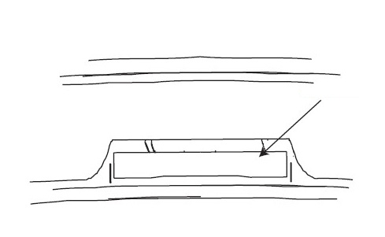
  - While carefully holding the bumper protector by its edges, partially pull the plastic liner at the end of the part 50mm to 75mm (2” to 3”) to remove it from the foam tape and create a tab that extends from the side of the part (Fig. 2-1).
Fig. 2-1
Peel tab
Back side of bumper protector
NOTE: Once the release liner is removed from the bumper protector, the surface of the tape must not be touched.

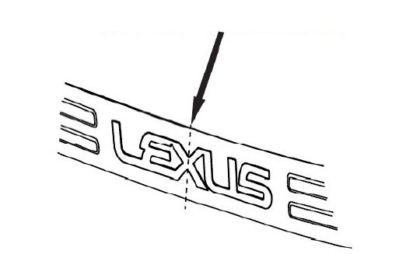
  - Hold the bumper protector about ½” above the surface of the bumper and align the center of the “X” on the bumper protector to the center of the latch on the rear lift gate (Fig. 2-2).
Fig. 2-2
Center the “X” to the latch
  - While keeping the bumper protector aligned, lower the part in place. Pull small sections of the backing while lightly tacking the part onto the bumper until you have removed all of the backing.
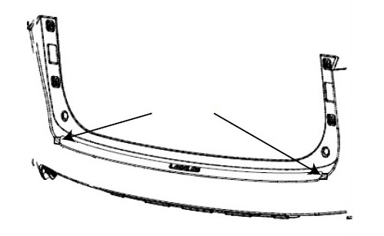
  - With the part lightly tacked down, remove the remaining tape tabs located at either end of the part (Fig. 2-3).
Fig. 2-3
Tape tabs

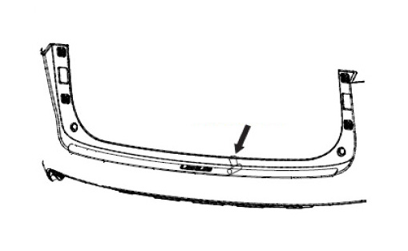
  - With both tape tabs removed, use the hard roller to roll around the perimeter of the part with at least 10 lbs. of pressure to ensure complete adhesion of the acrylic foam tape to the bumper surface (Fig. 2-4).
Fig. 2-4
Roller
Hard roller

Accessory Function Checks
Visual alignment

Proper tape adhesion

Vehicle Function Checks

The bumper protector should be visually centered left to right
The rear edge of the bumper protector should appear visually parallel to the rear edge of the vehicle bumper
The bumper protector should not extend back out over the rear of the bumper where the bumper surface starts to transition to vertical surfaces
A gap of approximately ½ mm is designed to exist between the edges of the bumper protector and the bumper

No gap is allowed between the tape and the bumper

Vehicle Appearance Check
After accessory installation and removal of protective cover(s), perform a visual inspection.

Ensure no damage (including scuffs and scratches) was caused during the installation process.
(For PPO installations, refer to TMS Accessory Quality Shipping Standard.)

